CUSTOMER REQUIREMENT SPECIFICATION

 |  |  |  | Document Ref.:
 |  |  |  | Version No.:
 |  |  |  | Date :
 | Project Name:
 | Project Code:
 | Status: | Draft / Current / Superseded
 | Document Type: | Controlled / Uncontrolled
 | <Title>
 | <Summary>
 | Prepared By: |  |  |  | Reviewed By:
 | Name |  | Date |  | Name |  |  | Date
 |  |  |  |  | Approved By:
 |  |  |  |  | Name |  |  | Date
 | Distribution List
 | Project Representative(s) |  |  |  |  | Guide Representative(s)
 | - <Name1>  - <Name2>  - <Name3> |  |  |  |  | - <Name4>  - <Name5>  - <Name6>

TABLE OF CONTENTS

Definitions, Acronyms and Abbreviations 3
References 3
Change History 4
1.0 Introduction 5
1.1 Scope 5
2.0 Product Perspective 5
2.1 User Characteristics 5
2.2 General Constraints, Assumptions and Dependencies 5
2.3 Risks 5
3.0 System Architecture 6
4.0 Requirements List 6
4.1 Module / Scenario 1 6
4.2 Module / Scenario 2 6
4.3 Module / Scenario n 6
5.0 External Interface Requirements 7
5.1 Hardware Requirements 7
5.2 Software Requirements 7
5.3 Communication Interfaces 7
6.0 User Interfaces 7
7.0 Performance Requirements 7
8.0 Special Characteristics 8
9.0 Help 8
10.0 Other Requirements 8
10.1 Site Adaptation Requirements 8
10.2 Safety Requirements 8
11.0 Packaging 8
12.0 Traceability Matrix 9

Definitions, Acronyms and Abbreviations
This section provides for definition of all terms, acronyms and abbreviations required for interpreting the CRS. Well known abbreviations need not be stated.
References
This section describes the complete list of documents referred to prepare the CRS. The reference documents shall describe the title, version number, dates, authors and publishers, whatever is applicable.
Change History
This section describes the details of changes that have resulted in the current CRS document.

# | Date | Document Version No. | Change Description | Reason For change

Introduction
The section shall introduce about the document, describe the purpose and audience for this document.

Scope
The scope of the project shall clearly define the coverage and limitations of the system.

Product Perspective
This section of the CRS puts the product into perspective with other related products or projects.
- State whether the product is independent and totally self-contained.
- If the product is a component of a larger system or project, then this should include:-
- Brief description of the functions of each component of the larger system or project and description of interfaces
- Identifying the principal external interfaces of this software product.
- Hardware, Software platforms used for development.
- Hardware, Software platforms used for deployment.

User Characteristics
This section of the CRS shall describe those general characteristics of the eventual users of the product that will affect the specific requirements.

General Constraints, Assumptions and Dependencies
This section of the CRS shall provide a general description of any other item that will limit the developer’s option for designing the system. These can include the following:
- Regulatory policies
- Hardware limitations. E.g. - signal timing requirements
- Software limitations like version of Operating Systems on which it should work
- Limitations of simulation programs
- Interfaces to other applications
- Parallel operations
- Criticality of application
- Safety and security consideration
This section shall list each of the factors that affect the stated requirements. These factors are not design constraints on the software but changes to them can affect the requirements.

Risks
This section describes the risks that involved during this phase. Risks may be related to the resource requirements or functionality of the proposed system.

System Architecture
Depict the initial requirements architecture diagram and give a brief explanation about the same or Context Diagram (Level “0” DFD) for the system being developed.
For Example:

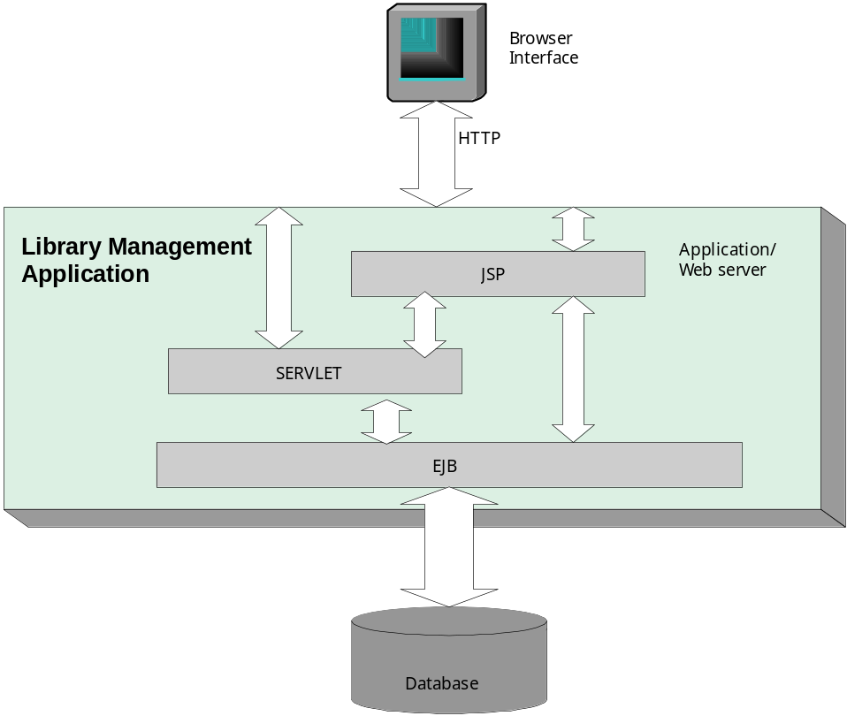
Your explanation comes here.

Requirements List

Module / Scenario 1
Reqmt # | Requirement
CRS – 1 | Describe the requirement Here

Module / Scenario 2
Reqmt # | Requirement
CRS – 1 | Describe the requirement Here

Module / Scenario n
Reqmt # | Requirement
CRS – 1 | Describe the requirement Here

External Interface Requirements

Hardware Requirements
This section specifies the logical characteristics of each interface between the software product and the hardware components of the system. It also covers such as what devices are to be supported, how they are to be supported, and protocols.

Software Requirements
This section shall specify the use of other required software products (e.g. a data management system, an operating system, or a mathematical package), and interface with other application systems (e.g. the linkage between an accounts receivable system and a general ledger system).
For each required product the following shall be provided
- Name and Description
- Version / Release Number
- Source (if any)

Communication Interfaces
This should specify the various interfaces to communications such as local area network protocols, serial ports, parallel ports, etc., and also line speed, buffer size and any other communication standards requirements if applicable

User Interfaces
This section shall specify
The characteristics that the software must support for each human interface of the software product. For e.g. if the user of the system operates through a display terminal, the following should be specified: -
- Required screen formats
- Page layout and content of any reports and menus
- Relative timing of inputs and outputs
- Availability of some form of programmable function key
All the aspects of optimizing the interfaces with the user who must use the system. This may simply comprise a list of dos and don’ts on how the system will appear to the user.

Performance Requirements
This section shall specify both static and dynamic numerical requirements placed on the software or on human interactions with the software, as a whole.
Static numerical requirements may include:-
- The number of terminals to be supported
- The number of simultaneous users to be supported
- Number of files and records to be handled
- Sizes of tables and files
- Dynamic numerical requirements may include:-
- The number of locations to which the system caters
- The number of transactions
- Tasks and the amount of data to be processed within certain time periods for both normal and peak workload conditions
- Compatibility between heterogeneous environments (for e.g. Open Systems, Mainframes, Mid-range systems, etc.)
- Interconnection between various networks (LAN, WAN, Internet, etc.)
- All the requirements should be stated in measurable terms.

Special Characteristics
This section shall specify the factors that would protect the software from accidental or malicious access, use, modifications, destruction, or disclosure. Specific requirements in this area could include the need to:
- Utilize certain cryptographic techniques
- Keep specific log or history data sets
- Assign certain functions to different modules
- Restrict communications between some areas of a program
- Compute checksums for critical quantities
- Hardware / Software locks for the product / package.

Help
This section shall describe the help planned for the system like, online / context sensitive help and other documentation (e.g. User Manual, Technical Manual) planned, to aid in the usage of the system. Refer User Manual Preparation Guidelines defined in section Rules, Practices and Conventions.

Other Requirements
Certain requirements may, due to the nature of the software and the user organization, be placed in separate categories as indicated below:

Site Adaptation Requirements
This section shall describe the following: -
- Define the requirements for any data or given site, mission, or operational mode, for example, grid values, safety limits etc.
- Specify the site or mission-related features that should be modified to adapt the software to a particular installation.

Safety Requirements
Identify the safety requirements that have to be addressed in the software. Eg. The Safety Standards prescribed by the customer to be mentioned here like HIPPA, Nuclear Safety or any other safety standard etc.,

Packaging
This section shall describe the software product to be packaged by considering the following: -
- Type of media
- Compressed / encrypted software (algorithm details, if specified

12.0 Traceability Matrix

URS Reference Section No. and Name | CRS Reference Section No. and Name

- The CRS is the basis for changes in specifications or requirements of the design in the project. It should be reflected in the Change History section.
- The CRS should state requirements and constraints clearly and concisely. Design details should not be included in the CRS.

